PROGRAM 4
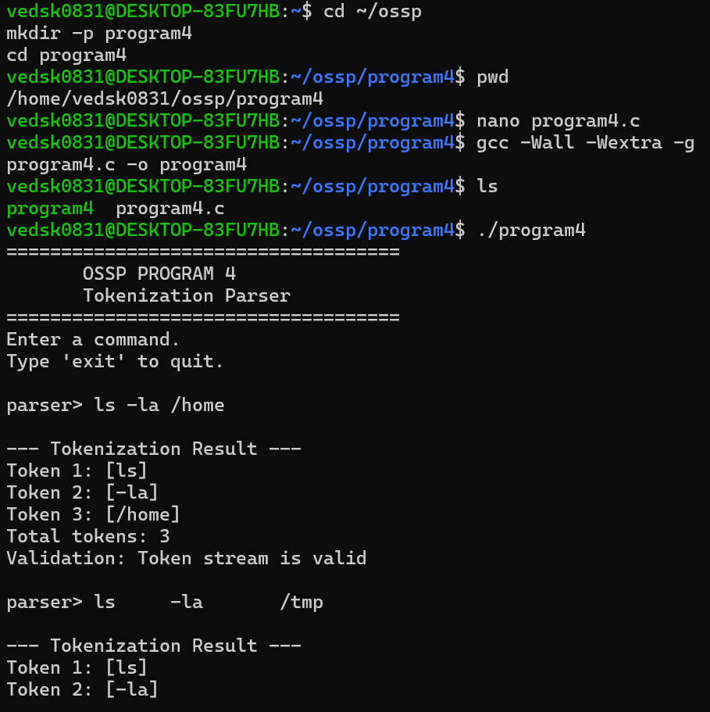
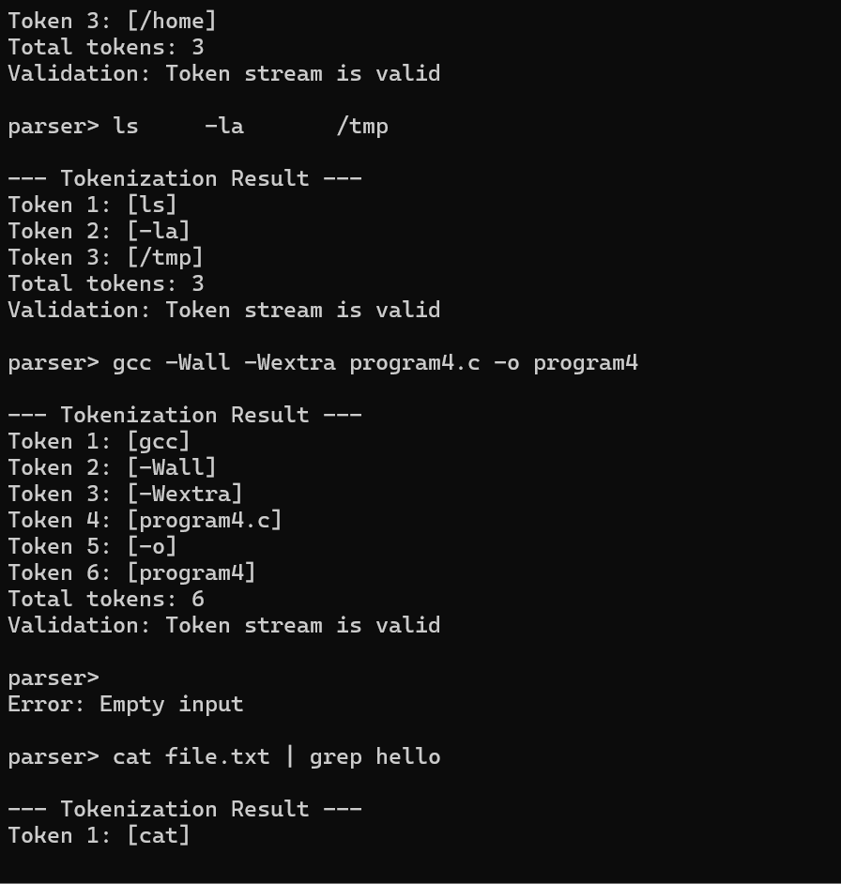
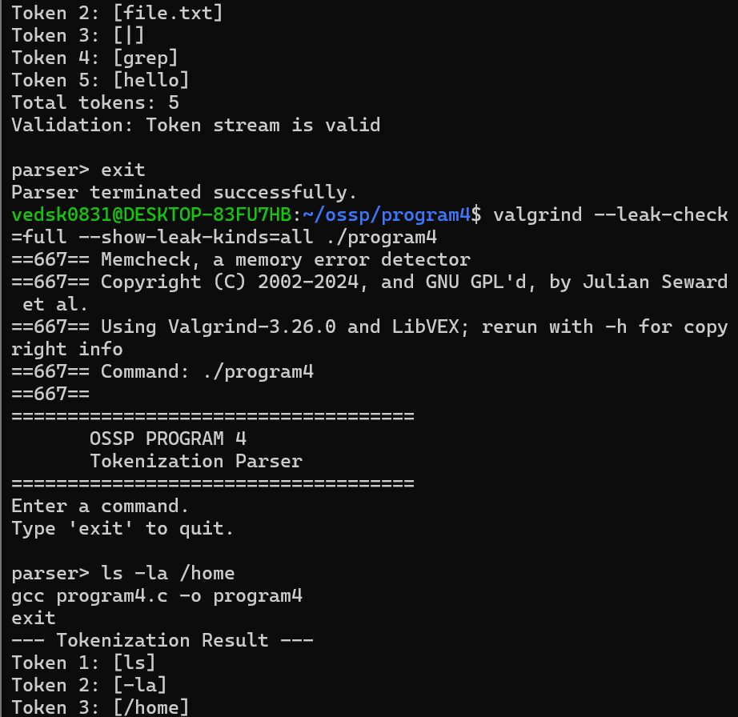
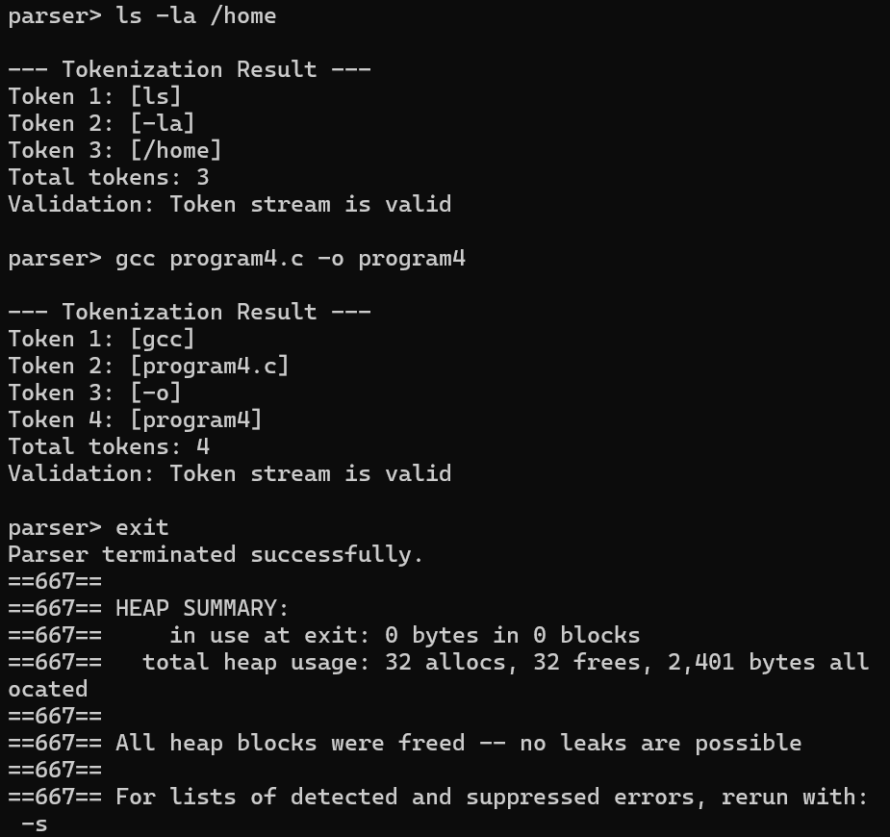
C PROGRAM
#include <stdio.h>
#include <stdlib.h>
#include <string.h>
#include <ctype.h>

#define MAX_INPUT 1024

typedef struct {
char **tokens;
int count;
} TokenList;

/* Free allocated token memory */
void free_tokens(TokenList *list)
{
for (int i = 0; i < list->count; i++) {
free(list->tokens[i]);
}

free(list->tokens);

list->tokens = NULL;
list->count = 0;
}

/* Add a token to the token list */
void add_token(TokenList *list, const char *start, int length)
{
char *token = malloc(length + 1);

if (token == NULL) {
perror("malloc");
exit(EXIT_FAILURE);
}

strncpy(token, start, length);
token[length] = '\0';

char **temp = realloc(
list->tokens,
(list->count + 1) * sizeof(char *)
);

if (temp == NULL) {
free(token);
perror("realloc");
exit(EXIT_FAILURE);
}

list->tokens = temp;
list->tokens[list->count] = token;
list->count++;
}

/* Tokenize input */
TokenList tokenize(const char *input)
{
TokenList list;

list.tokens = NULL;
list.count = 0;

int i = 0;

while (input[i] != '\0') {

/* Ignore whitespace */
while (isspace((unsigned char)input[i])) {
i++;
}

if (input[i] == '\0') {
break;
}

int start = i;

/* Read until whitespace */
while (input[i] != '\0' &&
!isspace((unsigned char)input[i])) {
i++;
}

add_token(
&list,
input + start,
i - start
);
}

return list;
}

/* Validate tokens */
int validate_tokens(const TokenList *list)
{
if (list->count == 0) {
printf("Validation: Empty command\n");
return 0;
}

printf("Validation: Token stream is valid\n");
return 1;
}

/* Display tokens */
void print_tokens(const TokenList *list)
{
printf("\n--- Tokenization Result ---\n");

for (int i = 0; i < list->count; i++) {
printf("Token %d: [%s]\n", i + 1, list->tokens[i]);
}

printf("Total tokens: %d\n", list->count);
}

int main()
{
char input[MAX_INPUT];

printf("====================================\n");
printf(" OSSP PROGRAM 4\n");
printf(" Tokenization Parser\n");
printf("====================================\n");

printf("Enter a command.\n");
printf("Type 'exit' to quit.\n\n");

while (1) {

printf("parser> ");

if (fgets(input, sizeof(input), stdin) == NULL) {
break;
}

/* Remove newline */
input[strcspn(input, "\n")] = '\0';

/* Handle empty input */
if (strlen(input) == 0) {
printf("Error: Empty input\n\n");
continue;
}

/* Exit condition */
if (strcmp(input, "exit") == 0) {
break;
}

/* Tokenize input */
TokenList list = tokenize(input);

/* Print tokens */
print_tokens(&list);

/* Validate token stream */
validate_tokens(&list);

/* Free memory */
free_tokens(&list);

printf("\n");
}

printf("Parser terminated successfully.\n");

return 0;
}

